## Design Question

For this I have proposed an architecture using Google Cloud, considering all the 5 requirements. A high-level solution design for the architecture is shown in the below Figure.

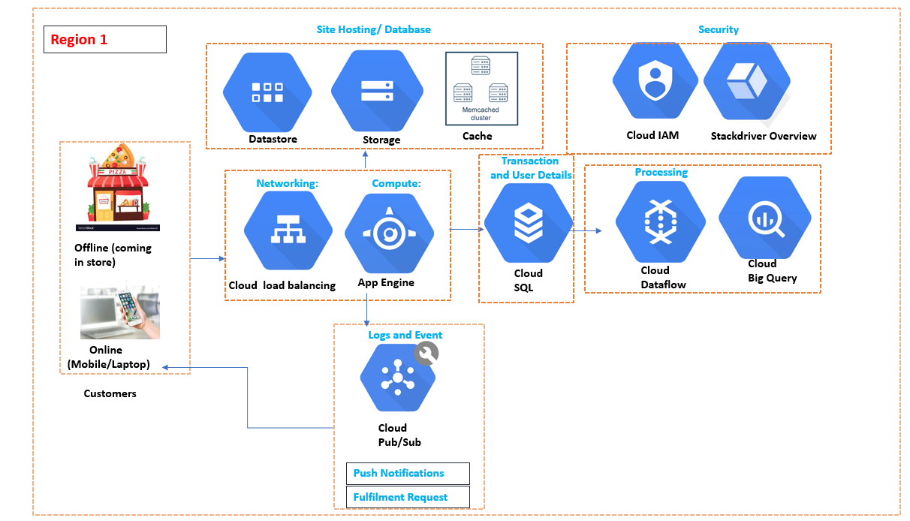

* **Cloud Load Balancing**

Evenly distributing and handling incoming requests through automatic scaling ensures App Engine isn’t overwhelmed by sudden increases in traffic. So, when dealing with un-predictable traffic and large amount of data so multiple cloud engines are running, so proper data processing coming from different store is evenly managed.

* **App Engine**

Fast limitless autoscaling and a ‘Pay as you go’ cost structure means its perfect for hosting your online store or mobile version.

* **Datastore**

Fully managed, autoscaling database, which specializes in handling huge amounts of read requests. Combine this with its ability to handle small *blob* files, and it is perfect for serving your product inventory to customers quickly.

* **Cloud Storage**

Perfect storage option for holding larger images and videos to be displayed on your store.

* **Memcache**

Used to cache common queries between App Engine and Datastore allowing for popular results to be returned quickly. Handle large read/query volume faster and more efficient way. Also read/Query patterns are time-series related metrics.

* **Cloud SQL**

Fully managed, secure autoscaling database for holding user accounts and handling purchase transactions, point of sales, order details, etc.

* **Pub/Sub**

Listen to all events within the system for both monitoring/maintenance and kickstarting additional processes.

* **Push Notifications**

Use Pub/Sub to provide real-time notifications to your customers using the Mobile App to give them updates on areas like new incoming promotions and offers and recent transactions.

* **Fulfilment Requests**

Use Pub/Sub to link the online store and your warehouse, by triggering fulfilment processes when a new purchase is completed.

* **Dataflow**

ETL service to transform events coming in to suit later analytical functions.

* **BigQuery**

Limitless scaling OLAP database for storing data which ready to be analysed.

* **Minimum Downtime**

Replication of Cloud Data-store, cloud storage and App Engine to the different datacenter in Region2. So, in terms of failure due to any reasons. Server downtime will only be negligible.